Lab 13 – Code Refactoring: Improving Legacy Code with AI Suggestions

Lab Objectives
- To introduce the concept of code refactoring and why it matters (readability, maintainability, performance).
- To practice using AI tools for identifying and suggesting improvements in legacy code.
- To evaluate the before vs. after versions for clarity, performance, and correctness.
- To reinforce responsible AI-assisted coding practices (avoiding over-reliance, validating outputs).
Learning Outcomes
After completing this lab, students will be able to:
- Use AI to analyze and refactor poorly written Python code.
- Improve code readability, efficiency, and error handling.
- Document AI-suggested improvements through comments and explanations.
- Apply refactoring strategies without changing functionality.
- Critically reflect on AI’s refactoring suggestions.
Task Description #1 – Remove Repetition
Task: Provide AI with the following redundant code and ask it to refactor

Python Code
def calculate_area(shape, x, y=0):
if shape == "rectangle":
return x * y
elif shape == "square":
return x * x
elif shape == "circle":
return 3.14 * x * x

Expected Output
- Refactored version with dictionary-based dispatch or separate functions.
- Cleaner and modular design.

Prompt: Refactor this Python function to remove repetition and make it more modular using a dictionary-based approach or separate function

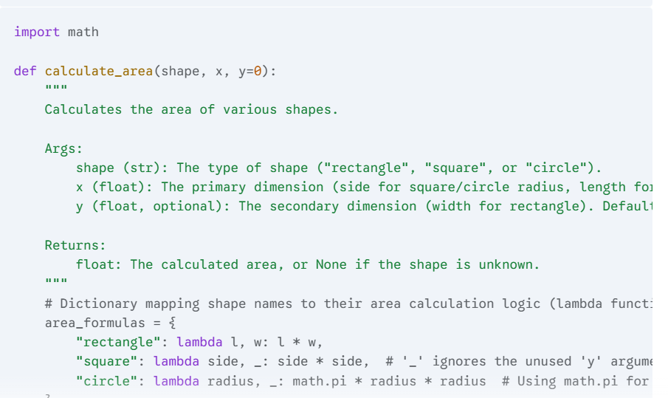

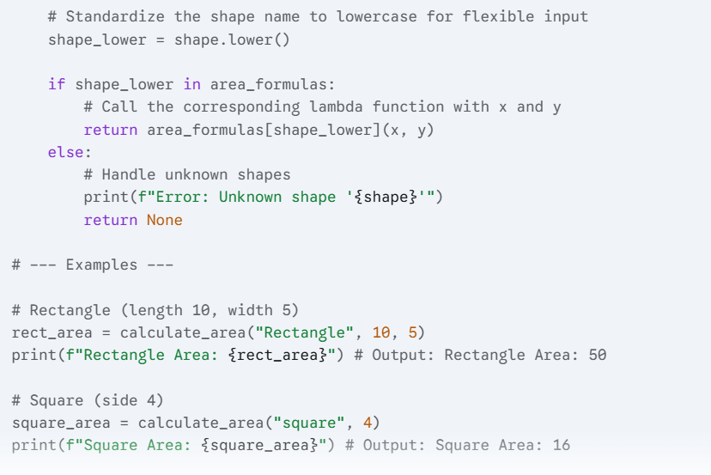

Task Description #2 – Error Handling in Legacy Code
Task: Legacy function without proper error handling

Python Code
def read_file(filename):
f = open(filename, "r")
data = f.read()
f.close()
return data

Expected Output:
AI refactors with with open() and try-except:

Prompt: Refactor this legacy file reading function to include proper error handling using try-except and with open() context management. Keep functionality the same

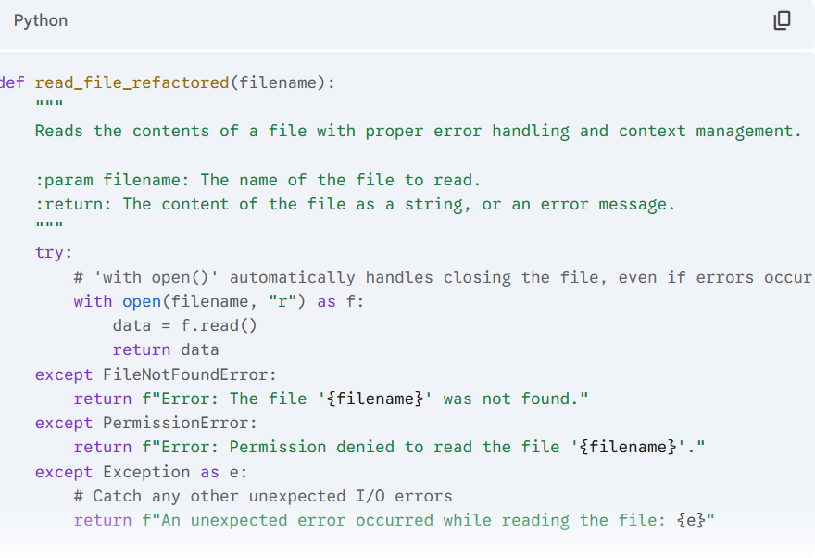

Task Description #3 – Complex Refactoring
Task: Provide this legacy class to AI for readability and modularity improvements:

Python Code
class Student:
def __init__(self, n, a, m1, m2, m3):
self.n = n
self.a = a
self.m1 = m1
self.m2 = m2
self.m3 = m3
def details(self):
print("Name:", self.n, "Age:", self.a)
def total(self):
return self.m1+self.m2+self.m3
Expected Output:
- AI improves naming (name, age, marks).
- Adds docstrings.
- Improves print readability.
- Possibly uses sum(self.marks) if marks stored in a list.

Prompt: Refactor this legacy Python class for better readability and modularity. Improve variable names, use a list for marks, add docstrings, and make print statements more readable

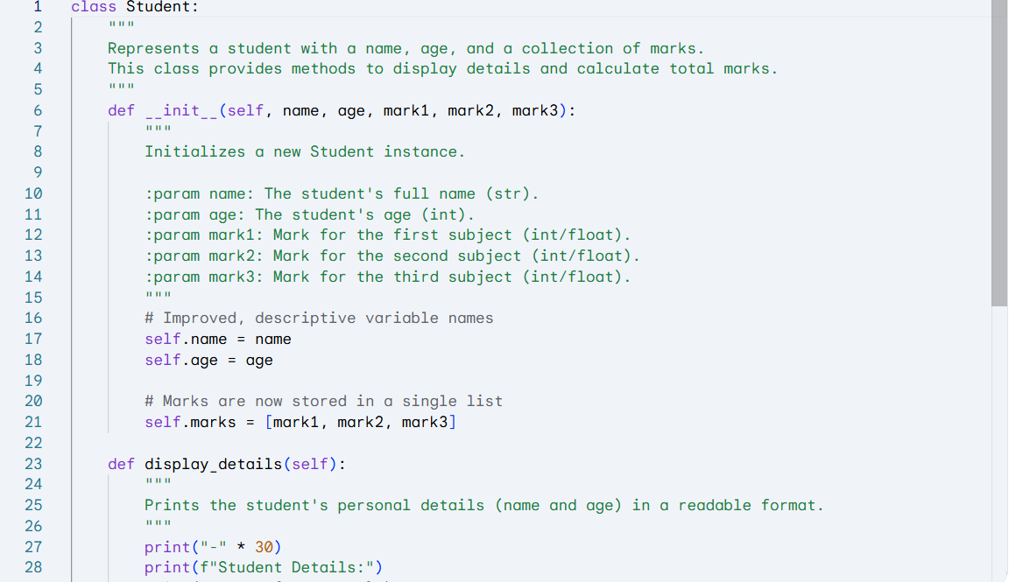

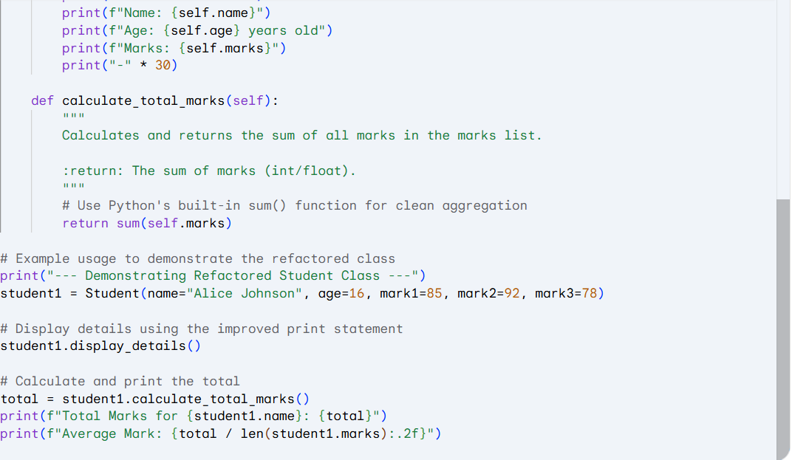

Task Description #4 – Inefficient Loop Refactoring
Task: Refactor this inefficient loop with AI help

Python Code
nums = [1,2,3,4,5,6,7,8,9,10]
squares = []
for i in nums:
squares.append(i * i)
Expected Output: AI suggested a list comprehension
Prompt: Refactor this inefficient Python loop using a more concise and Pythonic approach, such as list comprehensions

